Images are automatically uploaded to your course files to a folder called “ImagesforQuizzes”, subfolders will be made for the category and subcategory (subcategory is optional – remove the /TopicQuizName) you type in the header above.

The image below is an example of
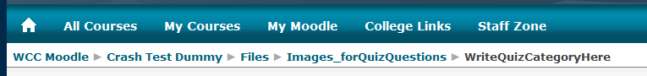
- Navigation
- Storyboarding
- Design
- Fun Stuff
Navigation example of breadcrumbs on Moodle
Question Names (titles) are optional. You NEED them for any question that is longer than two lines, or Moodle will not import the question. Yes… this Question Name is way too long…
Feedback needs to go after each question. At the moment it only works for the entire question – not after each answer / choice.
This is a comment. It doesn’t get imported by Moodle. You must provide at least two questions and three answers. You can provide extra wrong answers by giving an answer with a blank question. Entries where both the question and the answer are blank will be ignored.

Match the following pairs:

USA
Washington, DC
Australia
Sydney
Great Britain
London
Did you get it? The Global Capitals! ;)

Word Template is great for making Quizzes
- Yes, it is!!
- No, it isn’t
- No, it isn’t
- No, it isn’t
If you didn’t get this right, you haven’t used the online interface

This is a true statement

This is an Essay Question (max 150 words)

What is your favourite Candy Bar?
Take Five
Peanut Butter Cup
Reese’s Pieces

This is a false statement

This is a missing word question

Numerical Question: What is 2 + 3?
5
0.5

